SIT302 Project

Administration Guide

Online Book Store



GROUP 6

YOUSEF NAIF A ALHARBI

NOHA JAMALI A SALEM

FAISAL ABDULLAH M BIN GHIMLAS

AHMED AL SHAMISI

ABDULLAH ALDOKHIIL

AVIRAJ KAMBOJ

JALAB JALBANI

# Table of Contents

Table of Contents 2

1.0 Introduction 3

1.1 Document Purpose 3

2.0 Administration Front-end manual 4

2.1 Accessing the admin front-end 4

3.0 Logging in as administrator 4

3.1 Setting up and administrative user account 4

3.2 Logging in as administrator 5

4.0 Managing products 6

4.1 Manage products home page 6

4.2 Add Product 6

4.3 Editing product details 7

5.0 Delivery Rates 8

6.0 Manual database backup 9

7.0 Bibliography 9

# 1.0 Introduction

## 1.1 Document Purpose

The purpose of this document is to provide a comprehensive user guide that will assist the front-end users of the system in use of the system. There are two key parts to the system:

|  |  |
| --- | --- |
| **Administration Section** | The administration section of the system allows the business owner to   * Update product catalogue * Update shipping information * View shipped and unshipped orders |

This document covers the administration section of the Online Store. In addition to the administration section, the document also explains:

1. Backup and Recovery of the database

# 2.0 Administration Front-end manual

## 2.1 Accessing the admin front-end

For security reasons, there is no link on the website to access the front end. The link to the administrative section is:

<http://domainname.com/admin/>

For example, when the system is run locally for testing purposes, the link to the website is

<http://localhost/assignment/>

Therefore, the link to the website’s administrative section will be

<http://localhost/assignment/admin/>

# 3.0 Logging in as administrator

## 3.1 Setting up and administrative user account

The administrator accounts cannot be created from the front-end. The administrator accounts have to be inserted into the database directly by the database administrator.

There is an administrator account that has already been setup for testing purposes. It is recommended that this account is deleted and new accounts are setup for security reasons.

The default admin user name: admin

The default admin password: password

***Creating a new administrative user***

A new administrative user can be created by following these steps:

1. Browse the “admin” table in the database. You will see the existing users

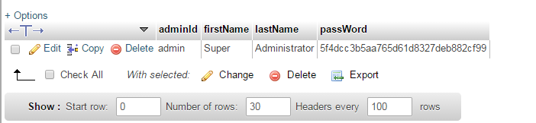

Figure

2. Click on “Insert”. Now, insert the data for the new administrator account. Please do not forget to select “MD5” option for the password.

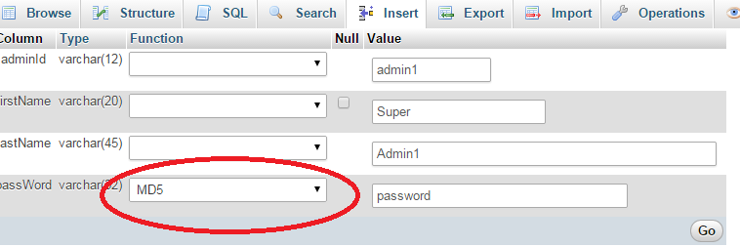

Figure

Now click on “Go”. Once you have clicked on “Go”, you will be taken back to the users which will display the new user.

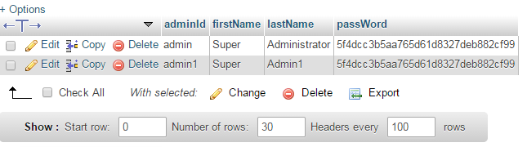

Figure

## 3.2 Logging in as administrator

In order to login as an administrator, go to the user.

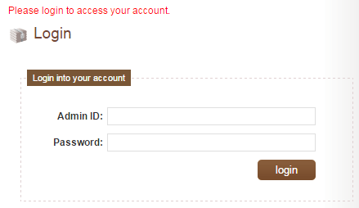

Figure

Enter the user id and password and click on “login”. You will see these details.

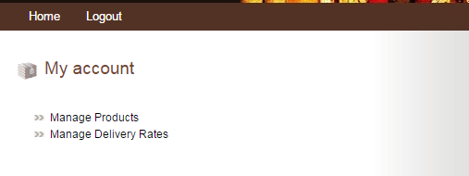

Figure

# 4.0 Managing products

## 4.1 Manage products home page

The manage products home page will display all of the products. For the products that cannot be deleted (because an order has already been placed for these products), you will see “Delete not Allowed”.

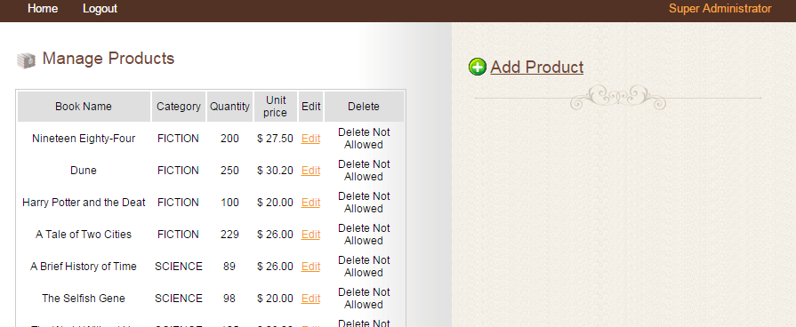

Figure

## 4.2 Add Product

In order to add a new product, you must select, “Add Product” from the right hand side. You will see the following form.

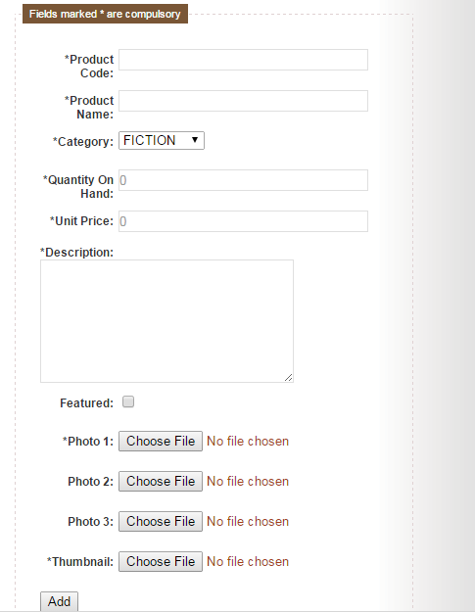

Figure

You can upload up to 4 product images in this page.

## 4.3 Editing product details

You can select “Edit” against any product. This will take you to a page that displays the details of the product. You can edit any of the details and then select “Update” to update these details about the product.

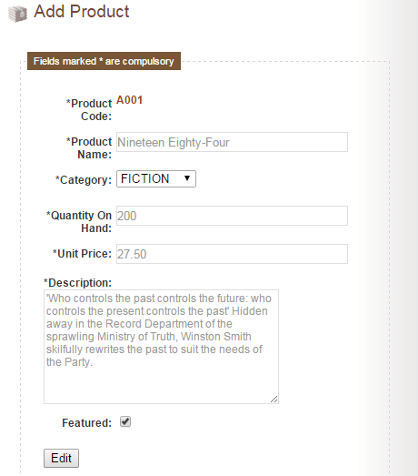

Figure

# 5.0 Delivery Rates

You can select the option “Manage Delivery Rates” to update the rate of delivery for each of the states.

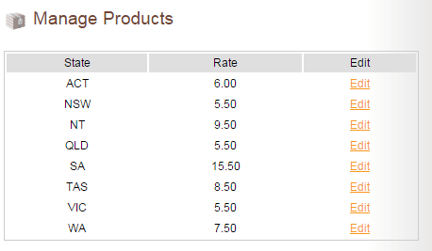

Figure

Select Edit on any of the states and you will get the option to edit the delivery rates for that particular state.

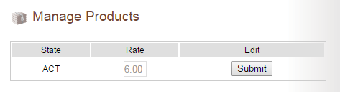

Figure

# 6.0 Manual database backup

There are already automatic backups of the data that are completed each week. However, if for some reason you had to take a manual backup of the system, you will need to contact the system administrator.

# 7.0 Bibliography

Paessler User Manual Template, Paessler Website, viewed on 25 January 2015 at <http://download-cdn.paessler.com/download/photomeistermanual.pdf>